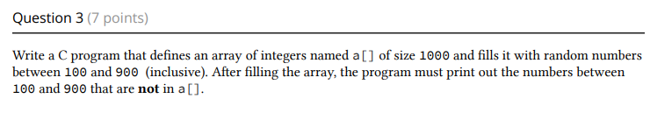

#include <stdio.h>

#include <time.h>

#include <stdlib.h>

#define size 1000

int main() {

srand(time(NULL)); /

int a[size],j[size],random_num,random_postnum;

for(int i=0;i<size;i++){

random_num= rand()%(900-100+1)+100;

a[i]=random_num;

printf("%d is in the array\n",a[i]);

}

for(int i=0;i<size;i++) {

j[i]=i;

}

for(int z=0; z<size;z++){

for(int f=0;f<size;f++){

if(j[z] != a[f]) {

printf("%d is not in array\n",j[z]);

break;

}

}

}

return 0;

}